**Guidance Bulletin** 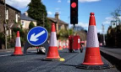

**No. 2021-03**

**CONE ZONE**

**Benefits of Safety Zones**

The safety zone is provided for two important reasons - firstly to protect you from traffic and secondly to protect the traffic from you.

The safety zone **must not** be entered in the normal course of work and materials and equipment **must not** be placed within the zone. It should **only** be entered to maintain cones and other road signs 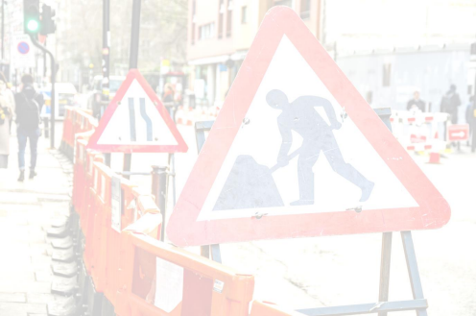

**Setting out Safety Zones**

When setting out cones, ensure sideways clearance is provided between the cones and the barriers. This should be 0.5m on roads 40mph or less, and 1.2m for 50mph and above.

Safety zones should be set out according to the code of practice (Red Book) and not omitted from the site. Zone dimensions are given inside the back cover of the Red Book and should be set out accordingly wherever possible.

Failure to comply can lead to death or serious injury to you and members of the public. Non-compliance could also lead to the issuing of a inadequacy notice or a prosecution under s65 (NRSWA) by a Highway Authority

When working on a footway, remember you must provide a safety zone in the carriageway if the working space is closer to the edge of the carriageway than the width of the sideways clearance.

If barriers or a pedestrian walkway are placed in the road, signing and guarding of the safety zone **must be carried out**.

This **must** be done before the footway is blocked. These same principles apply when working in a verge adjacent to the

carriageway.

**\*HAUC(UK) thanks Morrison Water Services in their help in the creation of this guidance. **

**This information is general guidance only and is not intended to replace specific legal advice. None of HAUC(UK) or its members, accept any liability for any action or omission taken based on this guidance.**